11. Find the largest of three numbers. Factorial of a number using Python

**Largest of three numbers**

**PROGRAM CODE**

a=int(input("Enter a:"))

b=int(input("Enter b:"))

c=int(input("Enter c:"))

if b>a:

print("b is greater than a")

elif c>b:

print("c is greater than b")

elif c<a:

print("c is greater than a")

else:

print(“Invalid”)

**OUTPUT**

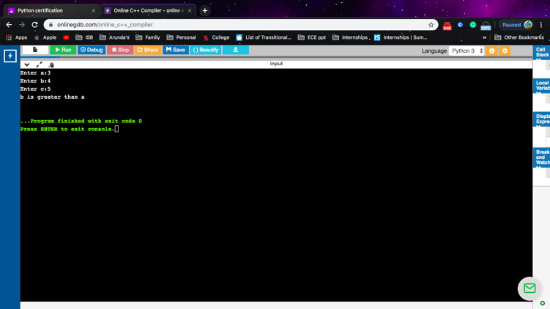

**Factorial of a number**

**PROGRAM CODE**

fact=1

num=int(input("Enter a positive integer to find factorial:"))

num=range(1,num+1)

for i in num:

fact=fact*i

print(fact)

**OUTPUT**

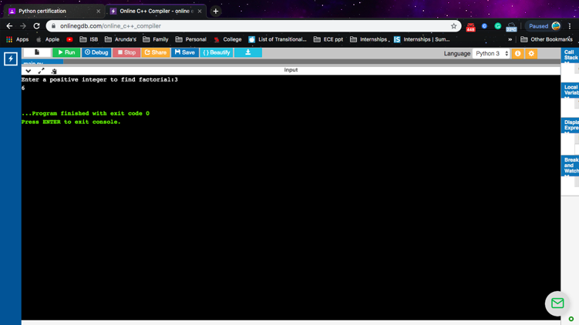

12.Write a Python program to make a calculator using Functions.

**PROGRAM CODE**

def add(num1,num2):

return num1+num2

def sub(num1,num2):

return num1-num2

def mul(num1,num2):

return num1*num2

def div(num1,num2):

return num1/num2

print("Select Operation:")

print("1.Add")

print("2.Subtract")

print("3.Multiply")

print("4.Divide")

choice=input("Enter a choice:")

number1=int(input("Enter first num:"))

number2=int(input("Enter second num:"))

if choice =='1':

print(number1,"+",number2,"=",add(number1,number2))

elif choice =='2':

print(number1,"-",number2,"=",sub(number1,number2))

elif choice =='3':

print(number1,"*",number2,"=",mul(number1,number2))

elif choice =='4':

print(number1,"/",number2,"=",div(number1,number2))

else:

print("Invalid input")

**OUTPUT**

